Tag Sale

MCj04398890000[1]

**When:** Saturday

June 29th, 2013

10:00 am to 4:00 pm

**Where**: 202 Meadowside Road**,** Milford, CT

Rain Date Saturday July 6th, 2013

Lemonade & Cookie Sale Too!

The cookies are so good we just have to say: “Come for the cookies – stay for the tag sale”

MCj02957650000[1] (While Supplies Last) MCj04398670000[1]

Anyone wishing to donate tag sale items that are clean and in good working order should

contact Erica Criscione at: (203) – 874 – 8882 or [EricaCanMakeaDifference@gmail.com](mailto:EricaCanMakeaDifference@gmail.com)

Erica is honored to be traveling in July 2013 as a proud member and Junior Leader of the

**People to People** Student Ambassador Program. Erica will be traveling Traditions of Europe to

England, Ireland, Wales and France. All proceeds will go to help cover Erica’s $6,999 program tuition.

Please visit Erica’s current website: [NeverMindWaldoWheresErica.Weebly.com](mailto:whereintheworldisericanow.weebly@.com)

   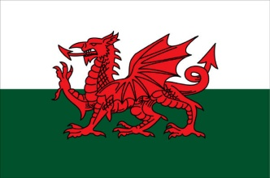 

Revised 3.5.13